**Installation of MySQL**

* Type MySQL download on Windows
* Go to MySQL community downloads
* Click on MySQL community server
* Scroll down and click on “Go To Download page”
* A new page opens. Scroll down. You will see as below:

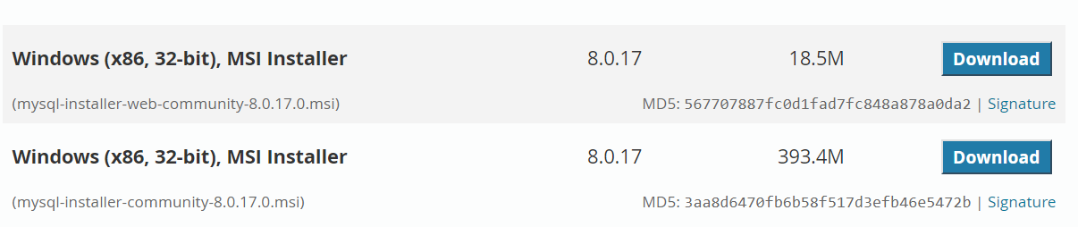

Click on the download button corresponding to the second file (which will be somewhere around 390 MB size). Do **NOT** click on download for the first file.

* A new page opens. Scroll down and click on the sentence shown as below:



This will download the **.msi file.**

* Double click on the installer file that is just downloaded.
* Windows installer dialogue box opens and Installer process is in place. Do not press any button.
* A dialogue pops up. Click yes.
* If a user control box pops up, click yes. After sometime, MySQL installer dialogue box opens.
* Click the check box for “I accept the license terms”. Click Next as shown below.

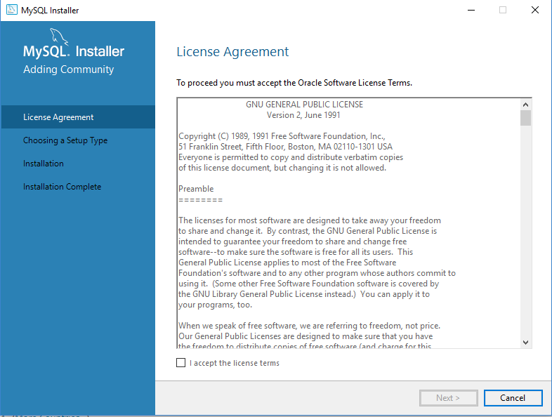

* By default “Developer default” radio button is selected. DO NOT make any changes. Click Next.

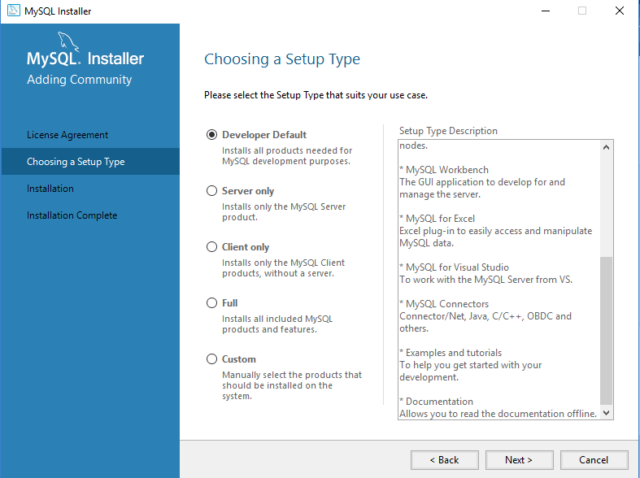

* ***Check Requirements*** dialogue box opens.
* A message asks “one or more requirements not satisfied, do you wish to proceed?”.. click yes.
* On the next window, click **execute**. This will install all the necessary packages.
* After the status is “Complete” for all the packages, click next.

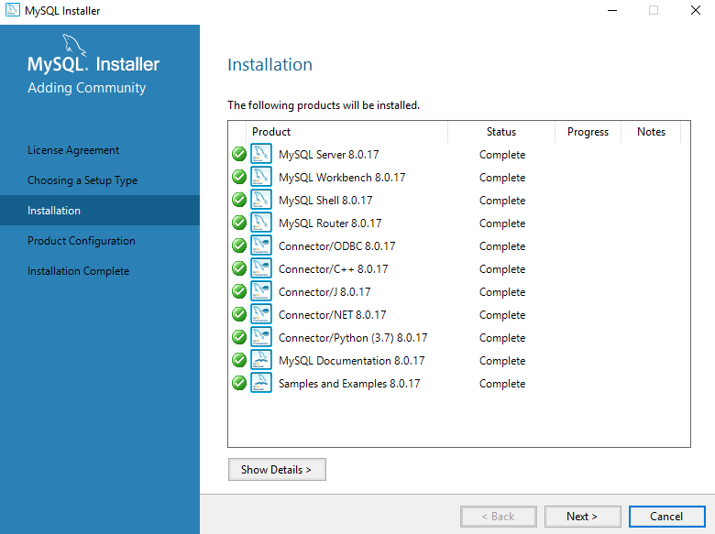

* Product configuration window opens. The status will be “Ready to Configure”. Click next.

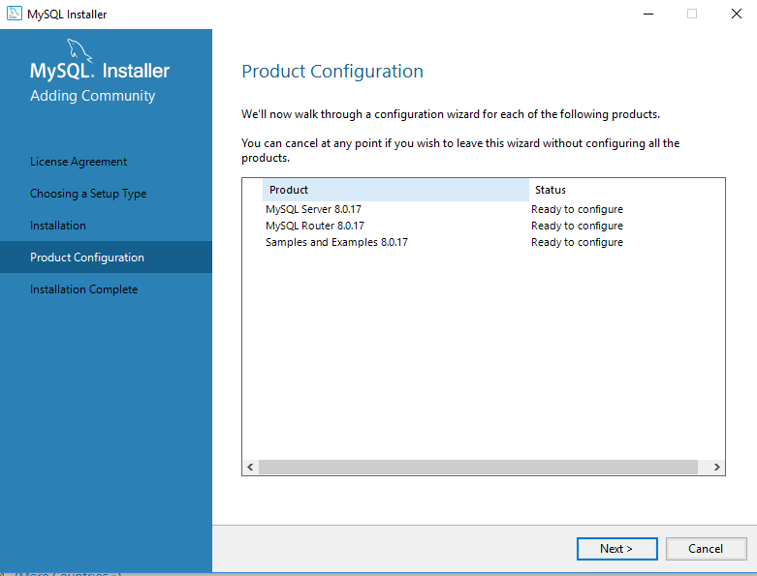

* ***High availability*** window opens. By default, Stand alone server is selected. Don’t make any changes here. Click Next.

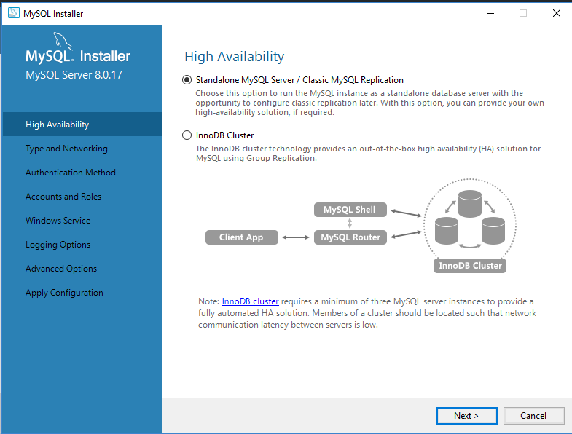

* ***Type and Networking*** window opens. Click next.

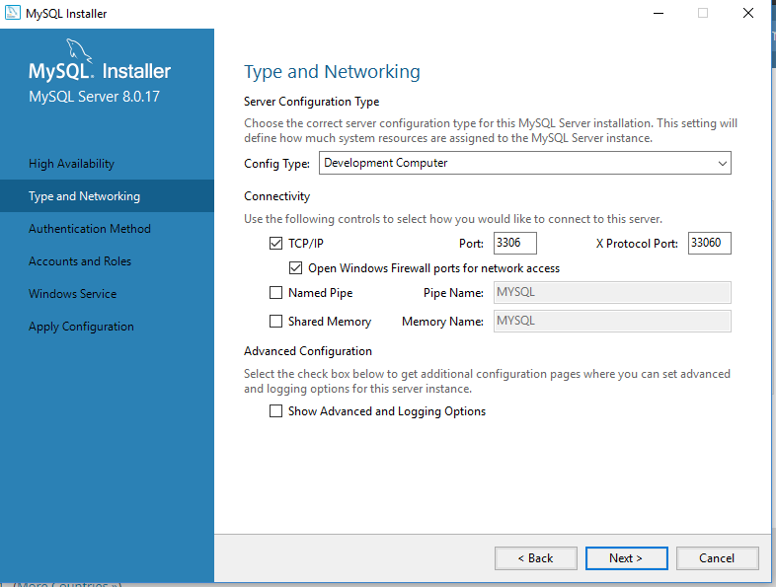

* Authentication method window opens. Keep the default. Do not make any changes in this window. Click Next.

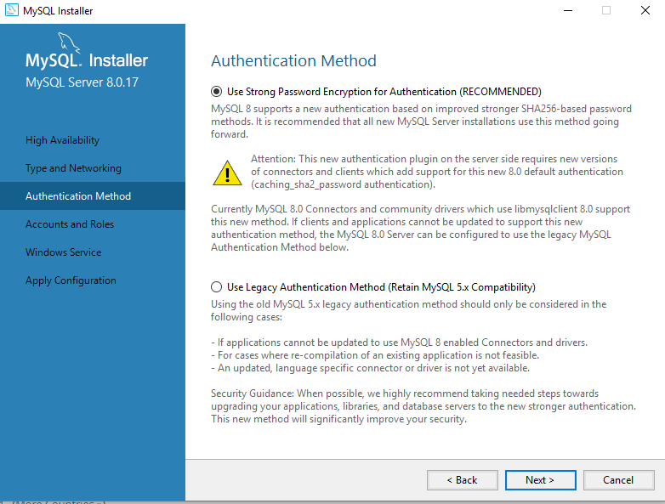

* Account and roles page opens. Provide the password of your choice and remember this. Click next.

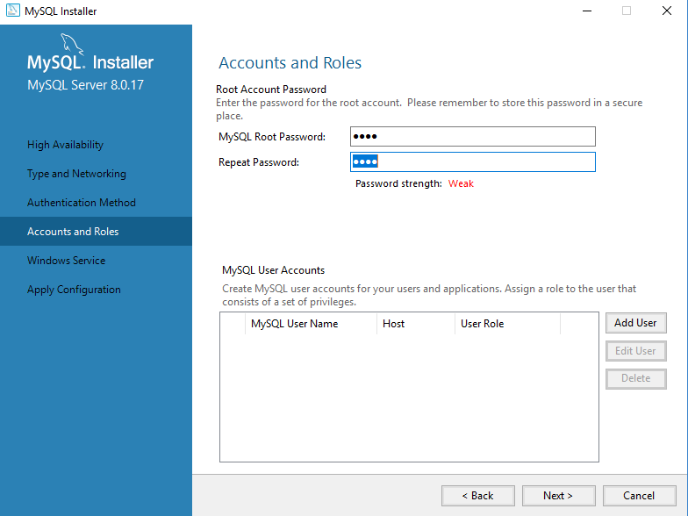

* Windows service dialogue box opens. Click Next.
* Apply configuration box opens. Click Execute.
* Click finish.
* Router configuration window opens. Click next, click finish.

Connect to server window opens. It will ask you to enter the password. Enter the password you had put in the earlier steps. Click “check”. A green tick mark appears saying Connection succeeded. This verifies that installation is proper. Click Next.

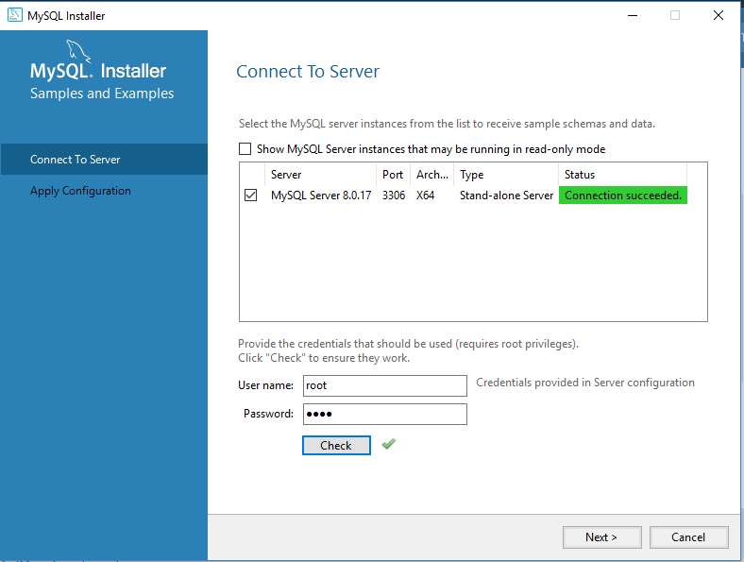

* In the next window, click execute. Click finish.
* On the ***Product Configuration*** window, click next.

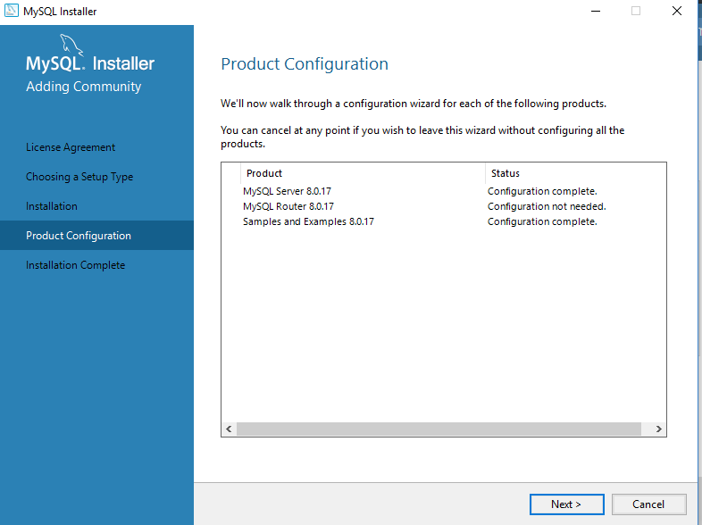

* Installation complete window opens as below.

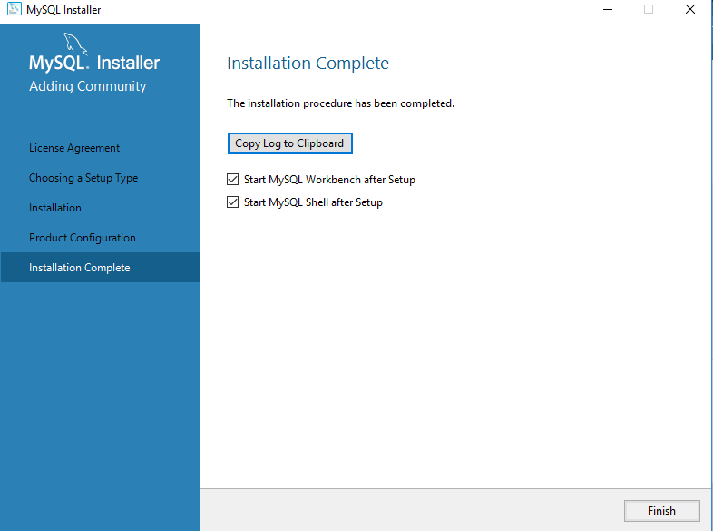

* Click finish.
* Close the shell script window if appears. The workbench for MySQL opens.
* In the Mysql workbench, click on “Local instance MySQL 80”.
* A window pops up asking you to enter the password. Put the password you had set earlier. Check the box for “save password in vault”. Click ok.

================================End of Installation process==========================